AutoCare+
Visual Documentation
Application Flow Diagram & Technology Architecture Diagram
Prepared for client handoff and stakeholder review
Document Version 1.0 · Draft
August 17, 2026
Source: AutoCare+ Software Requirements Specification & System Architecture

About This Document
This document presents three references for the AutoCare+ application: a plain-language project description, how a member moves through the app from sign-up to service completion, and what technology the app is built on. All three are simplified from the full technical specification so they can be reviewed and discussed without a technical background.
Everything in this document is drawn directly from the project's Software Requirements Specification and System Architecture documentation. Nothing here is speculative — where a feature is planned for a later release rather than the first version, that is explicitly noted.

Contents
- Part 1 — Project Description
- Part 2 — Application Flow Diagram
  - End-to-End Journey Overview
  - Core In-App Service Flow
  - Handoff Notes for Non-Technical Readers
- Part 3 — Technology Architecture Diagram
  - The Four-Layer Architecture
  - Technology at a Glance
  - Handoff Notes for Non-Technical Readers

Part 1 — Project Description
A short, plain-language description of AutoCare+ for anyone seeing the project for the first time.

What is AutoCare+?
AutoCare+ is a subscription-based car care app for Zamboanga City. Instead of only visiting a repair shop when something breaks, members pay a monthly membership and get ongoing, proactive care for their vehicle — inspections, maintenance reminders, pick-up and delivery, roadside help, and a simple health score that shows exactly how their car is doing at any time.

The problem
Most car owners only think about maintenance when something has already gone wrong. Small issues go unnoticed until they turn into expensive repairs or a breakdown on the road. And when it's time to sell a car, there's usually no real proof of how well it was maintained — just the seller's word.

The solution
AutoCare+ shifts car care from reactive to proactive. Members get:
- Scheduled inspections and reminders, so maintenance happens on time, before small problems become big ones
- A Vehicle Health Score — a simple number and star rating that sums up the car's condition, with plain-language explanations for every finding
- A “What Needs Attention” home screen, so members always know exactly what to do next, without digging through menus
- Pick-up and delivery, so getting a car serviced doesn't mean losing a day
- Roadside assistance, tracked live in the app, for breakdowns and emergencies
- A digital service history tied to the vehicle, replacing paper receipts and giving buyers real proof of maintenance at resale time

Who it's for
- Vehicle owners in Zamboanga City who want convenient, predictable car care and peace of mind
- Busy professionals and multi-car families who value not having to personally drop off and pick up a vehicle
- Fleet operators (delivery fleets, jeepney cooperatives) who need multiple vehicles maintained reliably

How members pay
Membership plans are priced monthly, with everything included clearly listed up front. Payment can be made in cash or through common e-wallets and cards (GCash, Maya, credit/debit) — whichever a member prefers.

What makes this different
Traditional repair shops are reactive and transactional — a customer shows up once something is already wrong. AutoCare+ is a relationship: continuous care, a digital record that follows the vehicle, and a health score that turns “trust me, it's well maintained” into something a buyer can actually verify.

Part 2 — Application Flow Diagram
This section shows how a member moves through the AutoCare+ app, from installing it to sharing a Vehicle Health Score certificate after a service.

How to read these diagrams
- Boxes are a screen, action, or system step.
- Arrows show what happens next.
- Diamond shapes are a decision point — the app or the member is choosing between paths.
- Colour groups steps that belong to the same stage or lane; it has no other meaning.
- Dashed arrows show an optional or secondary path.

Diagram 1 — End-to-End Journey Overview
The big picture: five stages every member passes through.
Figure 1. AutoCare+ member journey, from onboarding through after-service.

What's happening at each stage
Stage | What the member experiences
1 · Getting Started | Downloads the app, verifies their phone number with a one-time code (OTP), agrees to the privacy policy, and registers their vehicle's basic details.
2 · Choose a Plan | Compares the Basic and Premium membership plans, picks a payment method (cash or e-wallet), and their subscription goes live.
3 · Using the App | Books services, checks vehicle health, or requests emergency help. See Diagram 2 for the full breakdown of this stage.
4 · Payment & Records | Pays in cash or through GCash/Maya/card, receives a digital receipt, and the visit is automatically added to the vehicle's permanent service history.
5 · After Service | Gets the vehicle back, and can optionally generate a shareable Health Score certificate — useful proof of maintenance if they ever sell the car.

Diagram 2 — Core In-App Service Flow
A closer look at Stage 3 above: the three things a member can do inside the app, and how each one unfolds.
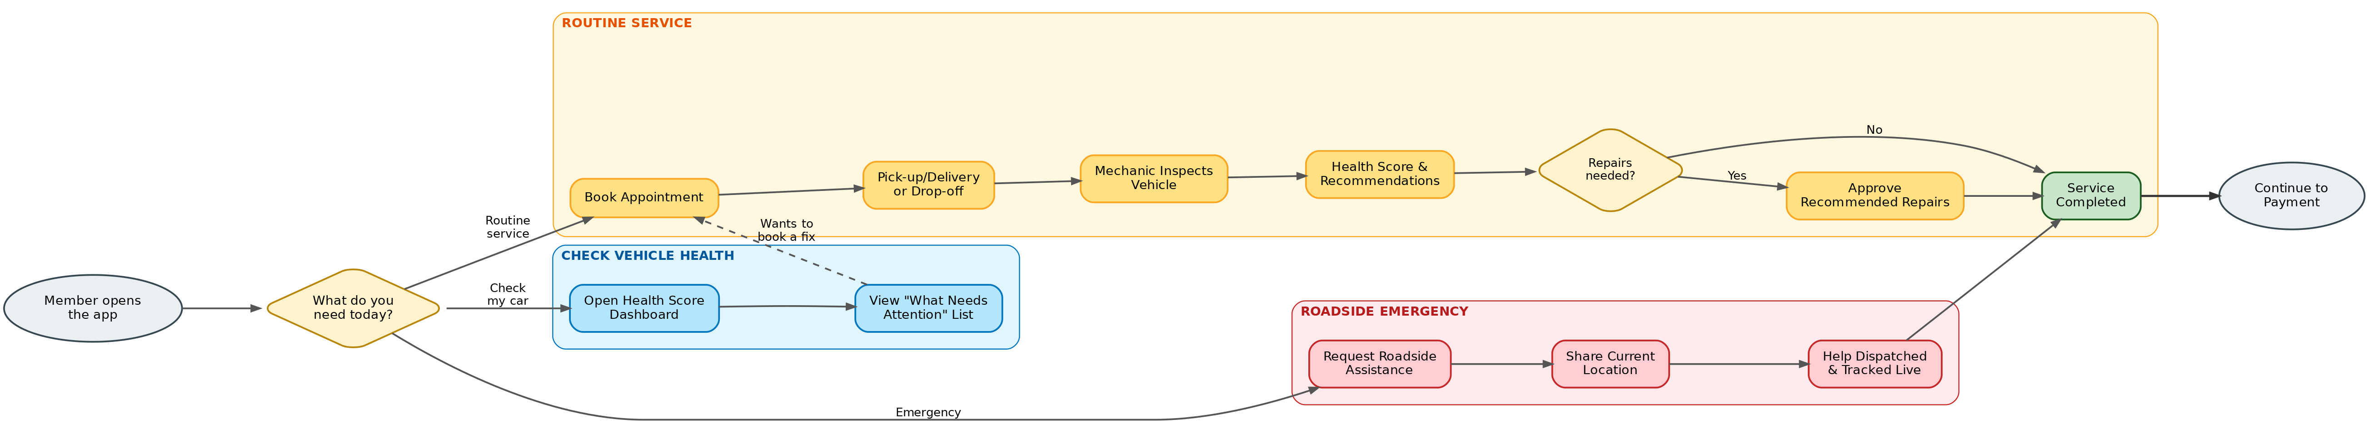
Figure 2. The three service paths — routine service, roadside emergency, and health check — and how they converge.

The three paths, explained
Routine Service (yellow)
The most common path. The member books a service, chooses pick-up or drop-off, a mechanic inspects the vehicle, and the app generates a Vehicle Health Score with any recommended repairs. If repairs are needed, the member approves them individually before any work happens — nothing is done to their car without their sign-off.
Roadside Emergency (red)
For breakdowns — a flat tyre, dead battery, or being stranded on the road. The member shares their location, and help is dispatched and tracked live in the app, the same way a ride-hailing app tracks a driver.
Check Vehicle Health (blue)
The member opens their dashboard at any time to see their car's current health score and a “What Needs Attention” list — a plain summary of anything that needs looking at. From there, they can jump straight into booking a fix.

Handoff Notes — Application Flow
This section exists so the flow diagrams can be shared with a non-technical client without needing a live walkthrough. It defines every term likely to cause confusion, and flags what's built now versus later.

Plain-language glossary
Term | What it means, in plain terms
OTP | “One-Time Password” — a temporary code sent by text message to confirm it's really the member signing up. The same thing used by banking apps.
Vehicle Health Score (VHS) | A single number and star rating summarizing how healthy the car is, generated automatically after every inspection — like a report card for the vehicle.
“What Needs Attention” list | A simple, always-visible list on the home screen telling the member exactly what to fix and why.
E-wallet | A digital payment app like GCash or Maya — the Philippine equivalent of a mobile wallet.
Digital service history | A permanent online record of everything ever done to the vehicle, replacing paper receipts.
Certificate | A shareable web link or PDF showing the car's health score and service history — useful when selling the car.

What's live now vs. planned later
Item | Status
Everything shown in Diagrams 1 and 2 | Included in the first release (v1.0)
An interactive visual diagram of the car itself (tap a part to see its condition) | Planned for a later release (v1.1) — not part of the first version

Questions a client will likely ask
Q: Does the member have to approve every single repair?
A: Yes — see the “Repairs needed?” decision point in Diagram 2. No work happens on a member's car without them explicitly approving it in the app first.
Q: Can a member pay in cash, or is it card-only?
A: Cash is fully supported, shown as “Pay by cash or e-wallet” in Stage 4. This was a deliberate choice to fit how Filipino consumers actually pay.
Q: Is this the final screen design?
A: No. These are flow diagrams showing the sequence of steps and decisions, not what the app will look like. Screen layouts are a separate design phase.

Part 3 — Technology Architecture Diagram
This section shows what AutoCare+ is built with, in four plain layers, and explains why each piece was chosen.

How to read this diagram
Think of it like a building: what people see (the apps), the engine room that does the work (the server), where records are filed (storage), and outside contractors the business relies on (payment providers, SMS, maps). Every arrow means “talks to” — information flows from the client apps down through the server to storage and outside services, and back.

The Four-Layer Architecture
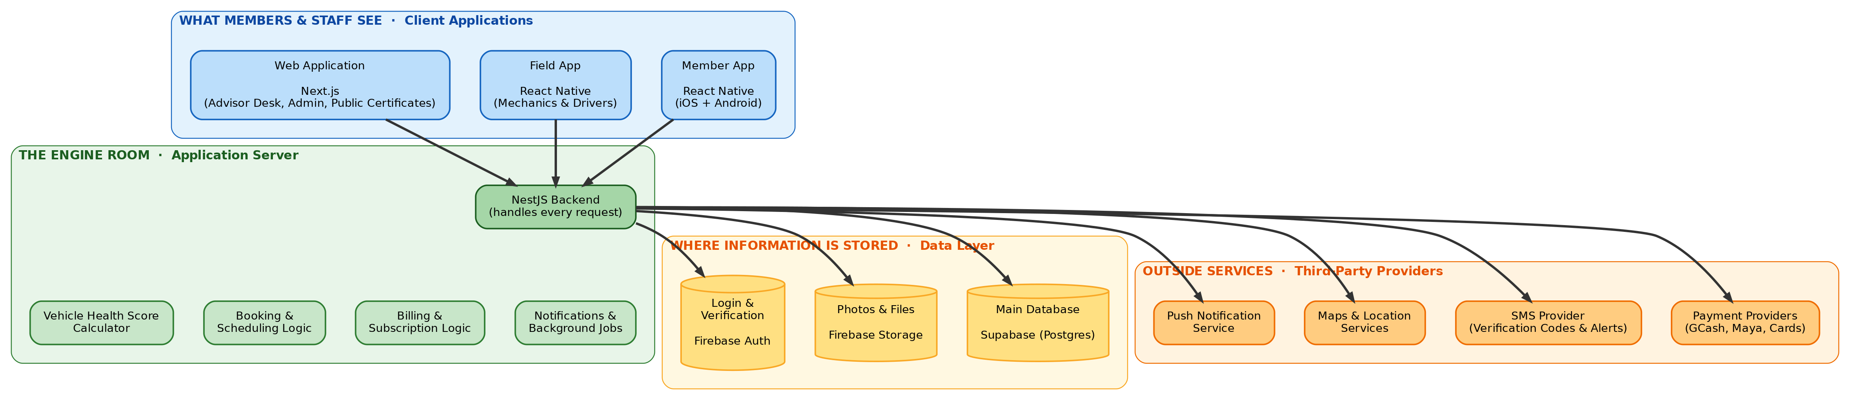
Figure 3. Client applications, application server, data storage, and outside services.

Technology at a Glance
Each row is a tool or service, what it actually does in plain terms, and which features it powers.
Technology | Plain-English purpose | Powers
React Native (Member App) | One codebase producing both the iOS and Android app. | Registration, booking, health scores, payments, roadside requests
React Native (Field App) | A separate app for mechanics and drivers, usable with no internet connection. | Inspections, trip tracking, cash collection
Next.js (Web Application) | One website codebase powering the advisor desk, admin dashboard, and public certificate pages. | Scheduling, reporting, pricing, shareable certificates
NestJS (Backend) | The central program every app talks to; enforces every business rule consistently. | Every feature, without exception
Vehicle Health Score Calculator | Turns an inspection into the 0–100 score and star rating. | Health scores, attention dashboard, certificates
Supabase (Postgres) | The main database where every record actually lives. | All records and history
Firebase Storage | Where photos and documents are kept. | Inspection photos, document uploads
Firebase Auth | Handles login and phone-number verification. | Sign-up, login, OTP verification
Payment Providers (GCash, Maya, Cards) | Lets members pay through e-wallets and cards without AutoCare+ handling raw card numbers. | Subscription billing, work-order payments
SMS Provider | Sends verification codes and critical alerts as text messages. | OTP delivery, critical alerts
Maps & Location Services | Turns a GPS pin into a readable address and shows a live map. | Pick-up requests, roadside tracking
Push Notification Service | Sends everyday reminders and updates. | Appointment reminders, status updates

Handoff Notes — Technology Architecture
Technology choices are one of the first things a client questions, especially around cost and vendor risk. This section pre-answers the likely questions in plain language.

Plain-language glossary
Term | What it means, in plain terms
Backend / server | The “engine room” — the part of the app nobody sees directly, but which does all the actual work.
Database | Where all information is permanently stored — every member, vehicle, booking, and inspection record.
API | The “language” the apps use to ask the server for information or tell it to do something.
Cloud hosting | The server and database run on rented computing infrastructure over the internet, rather than a physical computer in the shop.
Free tier | Several outside tools offer a free usage allowance before any cost kicks in, keeping early costs low.
Third-party provider | A company AutoCare+ pays or partners with instead of building that capability itself.
Vendor lock-in | The risk of depending so heavily on one outside provider that switching later becomes difficult.

Questions a client will likely ask
Q: Why so many outside tools instead of building everything in-house?
A: Each of these is a solved problem elsewhere, and building any one from scratch (especially payments) would take months and carry real risk. Using established providers means faster delivery and fewer places for something to go wrong, while all business logic stays custom-built and owned by the business.
Q: What if one of these companies raises prices or shuts down?
A: The backend is built so the database and login service can be swapped for a different provider without rewriting the apps. The system isn't permanently tied to any one vendor.
Q: Does the business own the app?
A: Yes. The architecture and all custom code belong entirely to the business. The outside services are pay-as-you-go tools the app uses, the same way a shop uses a card payment terminal without owning the card network.
Q: Is customer data safe?
A: Yes — passwords and sensitive data are encrypted, card numbers never touch AutoCare+'s own servers, and every sensitive action is logged, in line with the Philippine Data Privacy Act.
Q: Why two mobile apps instead of one?
A: Members and staff need very different things. Members need a polished, simple app; mechanics and drivers need something that works reliably in the field with a spotty signal. Separating them keeps each app focused for its actual audience.

End of document. For full technical detail, see the AutoCare+ Software Requirements Specification and System Architecture documentation.

